AI Systems Work1

**Name:** Cao Xinyang

**HDU Number:** 20321308

**Job issue for the work:**

Draw a family tree and write the corresponding code.

**Graph of the family tree:**

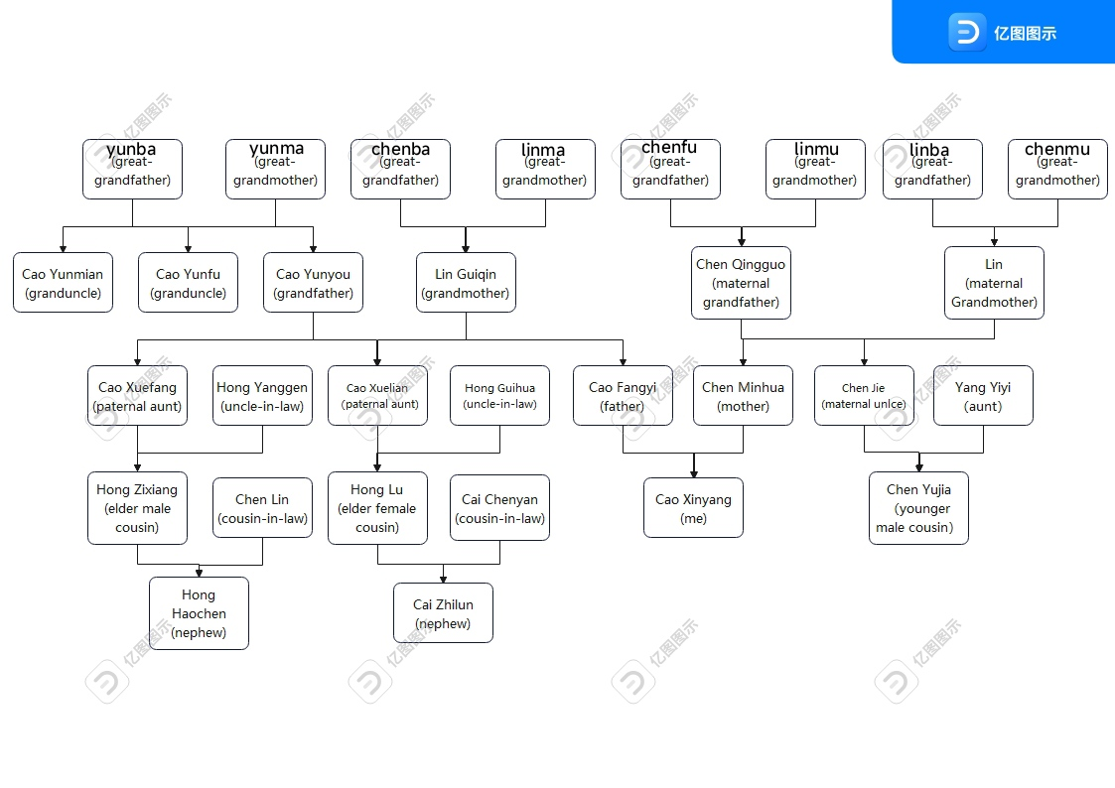

**My Code:**

%facts

%birth(father,mother,child,gender,year)

birth(yunba,yunma,yunmian,male,1939).

birth(yunba,yunma,yunyou,male,1941).

birth(yunba,yunma,yunfu,male,1943).

birth(chenba,linma,guiqin,female,1943).

birth(chenfu,linmu,qingguo,male,1944).

birth(linba,chenmu,lin,female,1946).

birth(yunyou,guiqin,xuelian,female,1965).

birth(yunyou,guiqin,xuefang,female,1967).

birth(yunyou,guiqin,fangyi,male,1971).

birth(qingguo,lin,minhua,female,1973).

birth(qingguo,lin,chenjie,male,1976).

birth(guihua,xuelian,honglu,female,1988).

birth(yanggen,xuefang,zixiang,male,1995).

birth(fangyi,minhua,xinyang,male,2001).

birth(chenjie,yiyi,yujia,male,2003).

birth(chenyan,honglu,zhilun,male,2012).

birth(zixiang,chenlin,haochen,male,2015).

%marriage(husband,wife,year)

marriage(yunba,yunma,1938).

marriage(chenba,linma,1940).

marriage(chenfu,linmu,1941).

marriage(linba,chenmu,1943).

marriage(yunyou,guiqin,1961).

marriage(qingguo,lin,1965).

marriage(guihua,xuelian,1986).

marriage(yanggen,xuefang,1990).

marriage(fangyi,minhua,1999).

marriage(chenjie,yiyi,2000).

marriage(chenyan,honglu,2010).

marriage(zixiang,chenlin,2013).

%divorce(husband,wife,year)

divorce(chenfu,linmu,1976).

%death(X,year)

death(chenfu,1990).

death(yunba,1994).

death(chenba,1999).

death(linba,2003).

death(yunma,2009).

death(chenmu,2013).

%like(name,hobby1,hobby2,hobby3,hobby4)

like(xinyang,singing,dancing,rap,basketball).

like(fangyi,apple,cooking,eating,running).

like(minhua,reading,walking,video,orange).

like(zixiang,driving,running,coke,climbing).

like(yujia,games,video,movies,singing).

like(honglu,reading,music,milk,dancing).

like(zhilun,games,swimming,basketball,milk).

like(haochen,running,jumping,hiking,video).

%rules

father(X,Y) :- birth(X,_,Y,_,_).

mother(X,Y) :- birth(_,X,Y,_,_).

male(X) :- birth(_,_,X,male,_).

female(X) :- birth(_,_,X,female,_).

son(X,Y) :- father(Y,X),male(X),!.

son(X,Y) :- mother(Y,X),male(X).

daughter(X,Y) :- father(Y,X),female(X),!.

daughter(X,Y) :- mother(Y,X),female(X).

brother(X,Y) :- father(Z,X), father(Z,Y), male(X), X\=Y,!.

brother(X,Y) :- mother(Z,X), mother(Z,Y), male(X), X\=Y.

sister(X,Y) :- father(Z,X), father(Z,Y), female(X), X\=Y,!.

sister(X,Y) :- mother(Z,X), mother(Z,Y), female(X), X\=Y.

younger_brother(X,Y) :- brother(X,Y), birth(_,_,X,_,Y1), birth(_,_,Y,_,Y2), Y1 < Y2.

elder_brother(X,Y) :- brother(X,Y), birth(_,_,X,_,Y1), birth(_,_,Y,_,Y2), Y1 > Y2.

younger_sister(X,Y) :- sister(X,Y), birth(_,_,X,_,Y1), birth(_,_,Y,_,Y2), Y1 < Y2.

elder_sister(X,Y) :- sister(X,Y), birth(_,_,X,_,Y1), birth(_,_,Y,_,Y2), Y1 > Y2.

grandfather(X,Y) :- father(X,Z), father(Z,Y),!.

grandfather(X,Y) :- father(X,Z), mother(Z,Y).

grandmother(X,Y) :- mother(X,Z), father(Z,Y),!.

grandmother(X,Y) :- mother(X,Z), mother(Z,Y).

cousin(X,Y) :- grandfather(Z,X), grandfather(Z,Y), X\=Y,!.

cousin(X,Y) :- grandmother(Z,X), grandmother(Z,Y), X\=Y.

uncle(X,Y) :- brother(Z,X), father(Z,Y),!.

uncle(X,Y) :- brother(Z,X), mother(Z,Y).

aunt(X,Y) :- sister(Z,X), father(Z,Y),!.

aunt(X,Y) :- sister(Z,X), mother(Z,Y).

nephew(X,Y) :- uncle(Y,X), male(X),!.

nephew(X,Y) :- aunt(Y,X), male(X).

niece(X,Y) :- uncle(Y,X), female(X),!.

niece(X,Y) :- aunt(Y,X), female(X).

granduncle(X,Y) :- uncle(X,Z),father(Z,Y),!.

granduncle(X,Y) :- uncle(X,Z),mother(Z,Y).

married(X, Year) :- marriage(X,Y,YofMarriage), Year > YofMarriage,

not(divorce(X,Y, _)), not(death(Y,_)).

**Goal resolutions:**

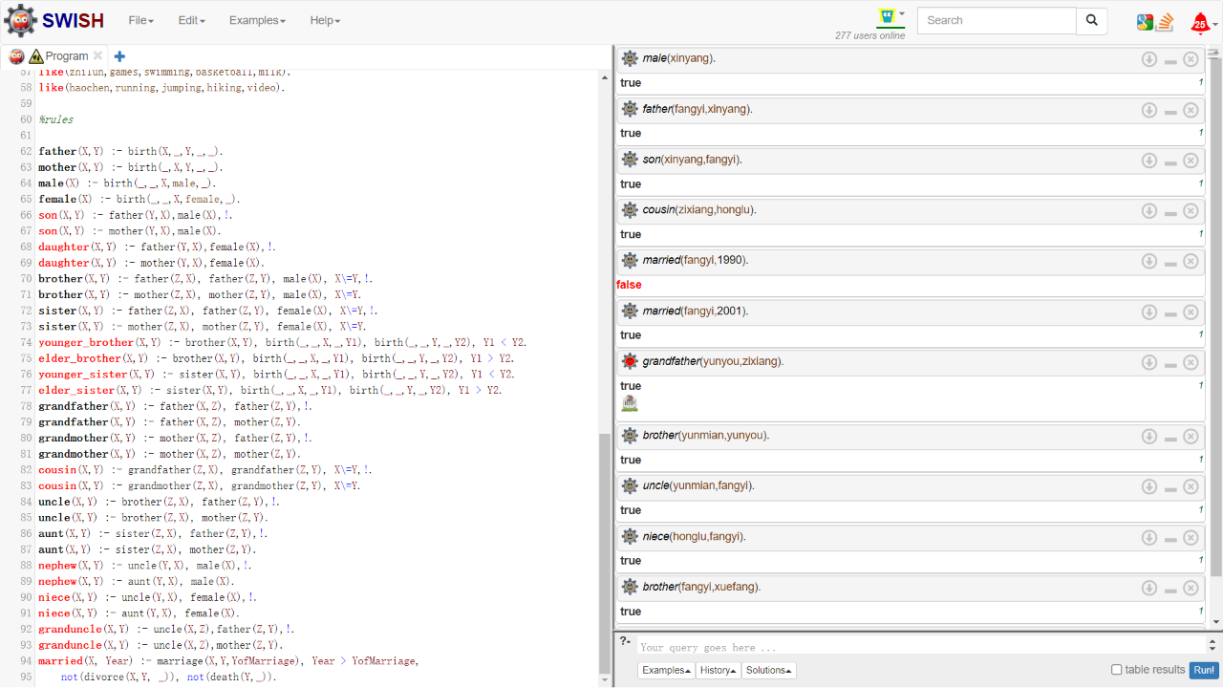

**Summary:**

By writing Prolog code, we can clearly understand the relationship between the roles, which is very useful.